Birthday cards, invite and video messages
Reception, Year 1 and Year 2

The NHS is important because:

- It is the health service that everybody in the UK can use when they become poorly or injured, to help them to get better.

- It is a free service which means people can be treated for free when they are poorly. Before the NHS, people would usually have to pay to get help if they got ill. It includes doctors, nurses, surgeons, ambulance drivers, opticians and all sorts of other people whose job it is to make sure people stay healthy.

We need your help! You need to:
- Design an invite to an NHS party
- Make a birthday card for the NHS
- Record yourself singing happy birthday whilst dressed up as an NHS worker (doctor, nurse,
ambulance driver)
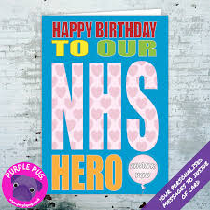
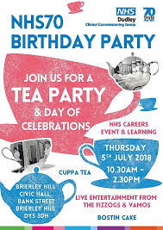

Menu and
birthday cake
Year 3 and Year 4

Today we are celebrating the NHS’s 72nd birthday. You are responsible for what we will eat at the party!
Your responsibilities include:

1. Create a healthy food menu for the
NHS’s party. Watch this video to learn about healthy eating. Think about the different healthy foods we can eat and enjoy. Here is a website with lots of ideas.

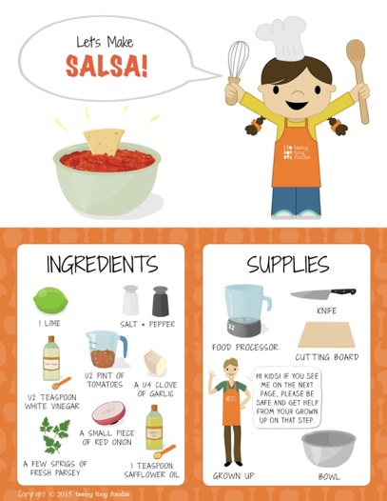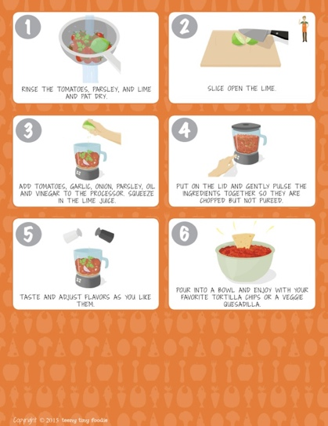

- Find a healthy cake recipe and write it down to share with your friends. You could look in a recipe book or check out this website for ideas.

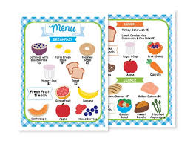
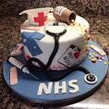
- Using the recipe you found, bake a cake for the NHS. Make sure you have the ingredients that you need.
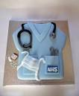
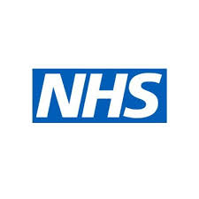
Invitation and Persuasion
Post your recipes and pictures of what you baked on Seesaw.
We will choose a selection to show at
Kabalat Shabbat.
Year 5 and Year 6

Who will we invite to our party?
The guest list should include people who have contributed to medicine and to the NHS over the last 72 years. Research different people and create a profile page explaining why you are inviting them. The people you invite can be from any time in history and from anywhere in the world, as long as they have contributed to the advancement of medicine. They could have invented vaccines, worked as nurses, developed ways of treating different illnesses or come up with how to keep frontline NHS staff safe.

Here is an example.

Aneurin Bevan 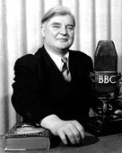
MP for Tredegar. Tredegar was a place with a local NHS before it was available to the whole country.
I am inviting him because he was Minister for Health at the time that the NHS was set up.
He had to work hard in parliament to overcome opposition to the NHS.

Post the profiles of the people you are inviting on Seesaw.

Can you persuade the government that the
UK needs an NHS?

Today the NHS is the health service that everybody in the UK can use when they become poorly or injured to help them get better. It is free to use and is paid for through taxes, which is money that UK adults pay to the government. The NHS includes doctors, nurses, surgeons, paramedics and all sorts of other people whose job it is to help people stay healthy.

We didn’t always have free health care. It all started in 1948, just after the war ended and the labour government believed that everyone should be able to get healthcare - no matter how much or little money they had. Before the NHS, people would usually have to pay to get help if they got ill.

In the beginning not everyone thought the NHS was a good idea. The government faced a lot of opposition to the NHS.

Your task today is to imagine that you are living in England before there was an NHS. You think it is a good idea but you know that not everyone agrees with you.

Write a persuasive letter to a newspaper or to your MP explaining why you think the NHS is such an amazing idea.

NHS information

Post your letter on Seesaw.
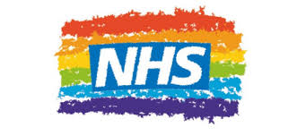

Song and Celebration

Write a song celebrating
the NHS!
Whole school activity

This is an opportunity to write a song celebrating the NHS. Write the song and film yourself singing the song. We will show some of the songs at Kabbalat Shabbat. Get your creative juices flowing! You can do this with friends or on your own. If they are really good we will send them to Newsround!

Here is an example of what another school did.
Here is a song for the NHS by Matty Cole
This is another song written for the NHS.

Video your song and post it on Seesaw!



